# Question 1

|  |  |  |  |  |  |  |  |  |  |  |  |
| --- | --- | --- | --- | --- | --- | --- | --- | --- | --- | --- | --- |
| p, j |  |  |  |  |  |  |  |  |  |  | r |
| 13 | 19 | 9 | 5 | 12 | 8 | 7 | 4 | 21 | 2 | 6 | 11 |

|  |  |  |  |  |  |  |  |  |  |  |  |
| --- | --- | --- | --- | --- | --- | --- | --- | --- | --- | --- | --- |
| p | j |  |  |  |  |  |  |  |  |  | r |
| 13 | 19 | 9 | 5 | 12 | 8 | 7 | 4 | 21 | 2 | 6 | 11 |

|  |  |  |  |  |  |  |  |  |  |  |  |
| --- | --- | --- | --- | --- | --- | --- | --- | --- | --- | --- | --- |
| p |  | j |  |  |  |  |  |  |  |  | r |
| 13 | 19 | 9 | 5 | 12 | 8 | 7 | 4 | 21 | 2 | 6 | 11 |

|  |  |  |  |  |  |  |  |  |  |  |  |
| --- | --- | --- | --- | --- | --- | --- | --- | --- | --- | --- | --- |
| p,i |  |  | j |  |  |  |  |  |  |  | r |
| 9 | 19 | 13 | 5 | 12 | 8 | 7 | 4 | 21 | 2 | 6 | 11 |

|  |  |  |  |  |  |  |  |  |  |  |  |
| --- | --- | --- | --- | --- | --- | --- | --- | --- | --- | --- | --- |
| p | i |  |  | j |  |  |  |  |  |  | r |
| 9 | 5 | 13 | 19 | 12 | 8 | 7 | 4 | 21 | 2 | 6 | 11 |

|  |  |  |  |  |  |  |  |  |  |  |  |
| --- | --- | --- | --- | --- | --- | --- | --- | --- | --- | --- | --- |
| p | i |  |  |  | j |  |  |  |  |  | r |
| 9 | 5 | 13 | 19 | 12 | 8 | 7 | 4 | 21 | 2 | 6 | 11 |

|  |  |  |  |  |  |  |  |  |  |  |  |
| --- | --- | --- | --- | --- | --- | --- | --- | --- | --- | --- | --- |
| p |  | i |  |  |  | j |  |  |  |  | r |
| 9 | 5 | 8 | 19 | 12 | 13 | 7 | 4 | 21 | 2 | 6 | 11 |

|  |  |  |  |  |  |  |  |  |  |  |  |
| --- | --- | --- | --- | --- | --- | --- | --- | --- | --- | --- | --- |
| p |  |  | i |  |  |  | j |  |  |  | r |
| 9 | 5 | 8 | 7 | 12 | 13 | 19 | 4 | 21 | 2 | 6 | 11 |

|  |  |  |  |  |  |  |  |  |  |  |  |
| --- | --- | --- | --- | --- | --- | --- | --- | --- | --- | --- | --- |
| p |  |  |  | i |  |  |  | j |  |  | r |
| 9 | 5 | 8 | 7 | 4 | 13 | 19 | 12 | 21 | 2 | 6 | 11 |

|  |  |  |  |  |  |  |  |  |  |  |  |
| --- | --- | --- | --- | --- | --- | --- | --- | --- | --- | --- | --- |
| p |  |  |  | i |  |  |  |  | j |  | r |
| 9 | 5 | 8 | 7 | 4 | 13 | 19 | 12 | 21 | 2 | 6 | 11 |

|  |  |  |  |  |  |  |  |  |  |  |  |
| --- | --- | --- | --- | --- | --- | --- | --- | --- | --- | --- | --- |
| p |  |  |  |  | i |  |  |  |  | j | r |
| 9 | 5 | 8 | 7 | 4 | 2 | 19 | 12 | 21 | 13 | 6 | 11 |

|  |  |  |  |  |  |  |  |  |  |  |  |
| --- | --- | --- | --- | --- | --- | --- | --- | --- | --- | --- | --- |
| p |  |  |  |  |  | i |  |  |  |  | r |
| 9 | 5 | 8 | 7 | 4 | 2 | 6 | 12 | 21 | 13 | 19 | 11 |

|  |  |  |  |  |  |  |  |  |  |  |  |
| --- | --- | --- | --- | --- | --- | --- | --- | --- | --- | --- | --- |
| p |  |  |  |  |  | i |  |  |  |  | r |
| 9 | 5 | 8 | 7 | 4 | 2 | 6 | 11 | 21 | 13 | 19 | 12 |

# Question 2

**start**

|  |  |  |  |  |  |  |  |  |
| --- | --- | --- | --- | --- | --- | --- | --- | --- |
| ***0*** | ***1*** | ***2*** | ***3*** | ***4*** | ***5*** | ***6*** | ***7*** | ***8*** |
|  |  |  |  | i |  |  |  |  |
| 5 | 3 | 17 | 10 | 84 | 19 | 6 | 22 | 9 |

**end**

|  |  |  |  |  |  |  |  |  |
| --- | --- | --- | --- | --- | --- | --- | --- | --- |
| ***0*** | ***1*** | ***2*** | ***3*** | ***4*** | ***5*** | ***6*** | ***7*** | ***8*** |
|  |  |  |  | i |  |  |  |  |
| 5 | 3 | 17 | 10 | 84 | 19 | 6 | 22 | 9 |

**Start**

|  |  |  |  |  |  |  |  |  |
| --- | --- | --- | --- | --- | --- | --- | --- | --- |
| ***0*** | ***1*** | ***2*** | ***3*** | ***4*** | ***5*** | ***6*** | ***7*** | ***8*** |
|  |  |  | i |  |  |  |  |  |
| 5 | 3 | 17 | 22 | 84 | 19 | 6 | 10 | 9 |

**end**

|  |  |  |  |  |  |  |  |  |
| --- | --- | --- | --- | --- | --- | --- | --- | --- |
| ***0*** | ***1*** | ***2*** | ***3*** | ***4*** | ***5*** | ***6*** | ***7*** | ***8*** |
|  |  |  | i |  |  |  |  |  |
| 5 | 3 | 17 | 22 | 84 | 19 | 6 | 10 | 9 |

**Start**

|  |  |  |  |  |  |  |  |  |
| --- | --- | --- | --- | --- | --- | --- | --- | --- |
| ***0*** | ***1*** | ***2*** | ***3*** | ***4*** | ***5*** | ***6*** | ***7*** | ***8*** |
|  |  | i |  |  |  |  |  |  |
| 5 | 3 | 17 | 22 | 84 | 19 | 6 | 10 | 9 |

**end**

|  |  |  |  |  |  |  |  |  |
| --- | --- | --- | --- | --- | --- | --- | --- | --- |
| ***0*** | ***1*** | ***2*** | ***3*** | ***4*** | ***5*** | ***6*** | ***7*** | ***8*** |
|  |  | i |  |  |  |  |  |  |
| 5 | 3 | 19 | 22 | 84 | 17 | 6 | 10 | 9 |

**Start**

|  |  |  |  |  |  |  |  |  |
| --- | --- | --- | --- | --- | --- | --- | --- | --- |
| ***0*** | ***1*** | ***2*** | ***3*** | ***4*** | ***5*** | ***6*** | ***7*** | ***8*** |
|  | i |  |  |  |  |  |  |  |
| 5 | 3 | 19 | 22 | 84 | 17 | 6 | 10 | 9 |

**End**

|  |  |  |  |  |  |  |  |  |
| --- | --- | --- | --- | --- | --- | --- | --- | --- |
| ***0*** | ***1*** | ***2*** | ***3*** | ***4*** | ***5*** | ***6*** | ***7*** | ***8*** |
|  | i |  |  |  |  |  |  |  |
| 5 | 84 | 19 | 22 | 3 | 17 | 6 | 10 | 9 |

**Start**

|  |  |  |  |  |  |  |  |  |
| --- | --- | --- | --- | --- | --- | --- | --- | --- |
| ***0*** | ***1*** | ***2*** | ***3*** | ***4*** | ***5*** | ***6*** | ***7*** | ***8*** |
| i |  |  |  |  |  |  |  |  |
| 5 | 84 | 19 | 22 | 3 | 17 | 6 | 10 | 9 |

**End**

|  |  |  |  |  |  |  |  |  |
| --- | --- | --- | --- | --- | --- | --- | --- | --- |
| ***0*** | ***1*** | ***2*** | ***3*** | ***4*** | ***5*** | ***6*** | ***7*** | ***8*** |
| i |  |  |  |  |  |  |  |  |
| 84 | 22 | 19 | 10 | 3 | 17 | 6 | 5 | 9 |

# Question 3

|  |  |  |  |  |  |  |  |  |  |  |  |
| --- | --- | --- | --- | --- | --- | --- | --- | --- | --- | --- | --- |
| ***0*** | ***1*** | ***2*** | ***3*** | ***4*** | ***5*** | ***6*** | ***7*** | ***8*** | ***9*** | ***10*** | ***11*** |
|  |  |  |  |  |  |  |  |  |  |  |  |
| 15 | 13 | 9 | 5 | 12 | 8 | 7 | 4 | 0 | 6 | 2 | 1 |



|  |  |  |  |  |  |  |  |  |  |  |  |  |
| --- | --- | --- | --- | --- | --- | --- | --- | --- | --- | --- | --- | --- |
| ***0*** | ***1*** | ***2*** | ***3*** | ***4*** | ***5*** | ***6*** | ***7*** | ***8*** | ***9*** | ***10*** | ***11*** | ***12*** |
|  |  |  |  |  |  |  |  |  |  |  |  | i |
| 15 | 13 | 9 | 5 | 12 | 8 | 7 | 4 | 0 | 6 | 2 | 1 | -99 |



|  |  |  |  |  |  |  |  |  |  |  |  |  |
| --- | --- | --- | --- | --- | --- | --- | --- | --- | --- | --- | --- | --- |
| ***0*** | ***1*** | ***2*** | ***3*** | ***4*** | ***5*** | ***6*** | ***7*** | ***8*** | ***9*** | ***10*** | ***11*** | ***12*** |
|  |  |  |  |  |  |  |  |  |  |  |  | i |
| 15 | 13 | 9 | 5 | 12 | 8 | 7 | 4 | 0 | 6 | 2 | 1 | 10 |



|  |  |  |  |  |  |  |  |  |  |  |  |  |
| --- | --- | --- | --- | --- | --- | --- | --- | --- | --- | --- | --- | --- |
| ***0*** | ***1*** | ***2*** | ***3*** | ***4*** | ***5*** | ***6*** | ***7*** | ***8*** | ***9*** | ***10*** | ***11*** | ***12*** |
|  |  |  |  |  | i |  |  |  |  |  |  |  |
| 15 | 13 | 9 | 5 | 12 | 10 | 7 | 4 | 0 | 6 | 2 | 1 | 8 |



|  |  |  |  |  |  |  |  |  |  |  |  |  |
| --- | --- | --- | --- | --- | --- | --- | --- | --- | --- | --- | --- | --- |
| ***0*** | ***1*** | ***2*** | ***3*** | ***4*** | ***5*** | ***6*** | ***7*** | ***8*** | ***9*** | ***10*** | ***11*** | ***12*** |
|  |  | i |  |  |  |  |  |  |  |  |  |  |
| 15 | 13 | 10 | 5 | 12 | 9 | 7 | 4 | 0 | 6 | 2 | 1 | 8 |



# Question 4

|  |  |  |  |  |  |  |  |  |
| --- | --- | --- | --- | --- | --- | --- | --- | --- |
| ***0*** | ***1*** | ***2*** | ***3*** | ***4*** | ***5*** | ***6*** | ***7*** | ***8*** |
|  |  |  |  |  |  |  |  | i |
| 84 | 22 | 19 | 10 | 3 | 17 | 6 | 5 | 9 |

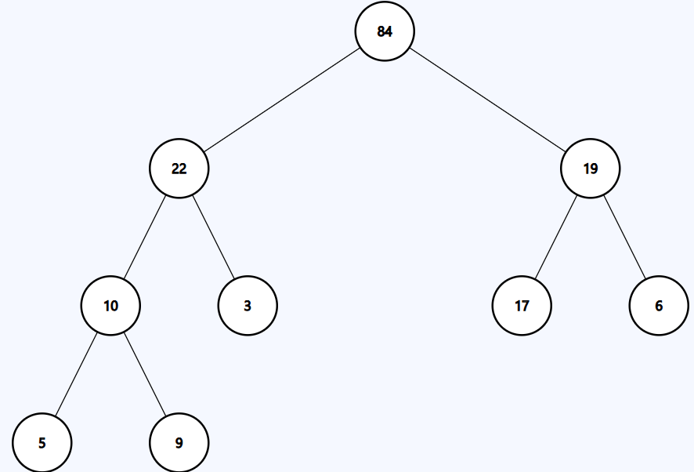

|  |  |  |  |  |  |  |  |  |
| --- | --- | --- | --- | --- | --- | --- | --- | --- |
| ***0*** | ***1*** | ***2*** | ***3*** | ***4*** | ***5*** | ***6*** | ***7*** | ***8*** |
|  |  |  |  |  |  |  | i |  |
| 22 | 10 | 19 | 9 | 3 | 17 | 6 | 5 | 84 |

|  |  |  |  |  |  |  |  |  |
| --- | --- | --- | --- | --- | --- | --- | --- | --- |
| ***0*** | ***1*** | ***2*** | ***3*** | ***4*** | ***5*** | ***6*** | ***7*** | ***8*** |
|  |  |  |  |  |  | i |  |  |
| 19 | 10 | 17 | 9 | 3 | 5 | 6 | 22 | 84 |

|  |  |  |  |  |  |  |  |  |
| --- | --- | --- | --- | --- | --- | --- | --- | --- |
| ***0*** | ***1*** | ***2*** | ***3*** | ***4*** | ***5*** | ***6*** | ***7*** | ***8*** |
|  |  |  |  |  | i |  |  |  |
| 17 | 10 | 6 | 9 | 3 | 5 | 19 | 22 | 84 |

|  |  |  |  |  |  |  |  |  |
| --- | --- | --- | --- | --- | --- | --- | --- | --- |
| ***0*** | ***1*** | ***2*** | ***3*** | ***4*** | ***5*** | ***6*** | ***7*** | ***8*** |
|  |  |  |  | i |  |  |  |  |
| 10 | 9 | 6 | 5 | 3 | 17 | 19 | 22 | 84 |

|  |  |  |  |  |  |  |  |  |
| --- | --- | --- | --- | --- | --- | --- | --- | --- |
| ***0*** | ***1*** | ***2*** | ***3*** | ***4*** | ***5*** | ***6*** | ***7*** | ***8*** |
|  |  |  | i |  |  |  |  |  |
| 9 | 5 | 6 | 3 | 10 | 17 | 19 | 22 | 84 |

|  |  |  |  |  |  |  |  |  |
| --- | --- | --- | --- | --- | --- | --- | --- | --- |
| ***0*** | ***1*** | ***2*** | ***3*** | ***4*** | ***5*** | ***6*** | ***7*** | ***8*** |
|  |  | i |  |  |  |  |  |  |
| 6 | 5 | 3 | 9 | 10 | 17 | 19 | 22 | 84 |

|  |  |  |  |  |  |  |  |  |
| --- | --- | --- | --- | --- | --- | --- | --- | --- |
| ***0*** | ***1*** | ***2*** | ***3*** | ***4*** | ***5*** | ***6*** | ***7*** | ***8*** |
|  | i |  |  |  |  |  |  |  |
| 3 | 5 | 6 | 9 | 10 | 17 | 19 | 22 | 84 |

## result

|  |  |  |  |  |  |  |  |  |
| --- | --- | --- | --- | --- | --- | --- | --- | --- |
| ***0*** | ***1*** | ***2*** | ***3*** | ***4*** | ***5*** | ***6*** | ***7*** | ***8*** |
|  |  |  |  |  |  |  |  |  |
| 3 | 5 | 6 | 9 | 10 | 17 | 19 | 22 | 84 |